Get responses tailored to you
Log in to get answers based on saved chats, plus create images and upload files.
Log in
🏕️ Al Ain Camping Sites for Motorhomes & Popup Truck Campers
(Remal Campers Rental Edition 🚐✨)
Al Ain is one of the best family-friendly camping destinations in the UAE, combining desert landscapes, mountain views, and peaceful nature. With Remal Campers Rental, you can enjoy a complete experience using Iveco motorhomes, camper trailers, and RAM popup truck campers—all set up with BBQ, lighting, and family comfort.

👨‍👩‍👧‍👦 Family Camping Setup (Kids + BBQ + Trailers & Motorhomes)
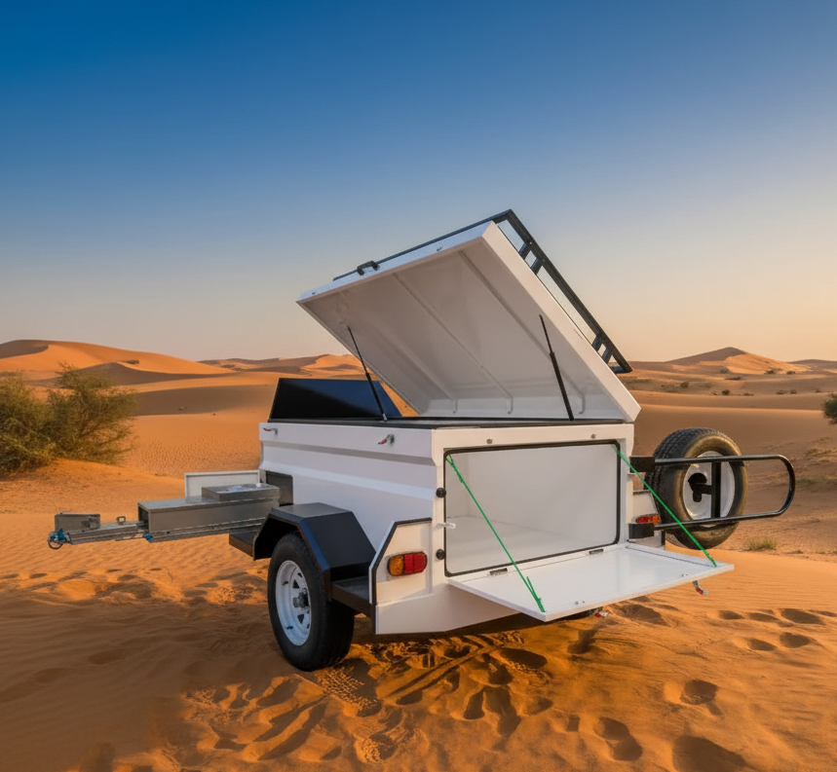
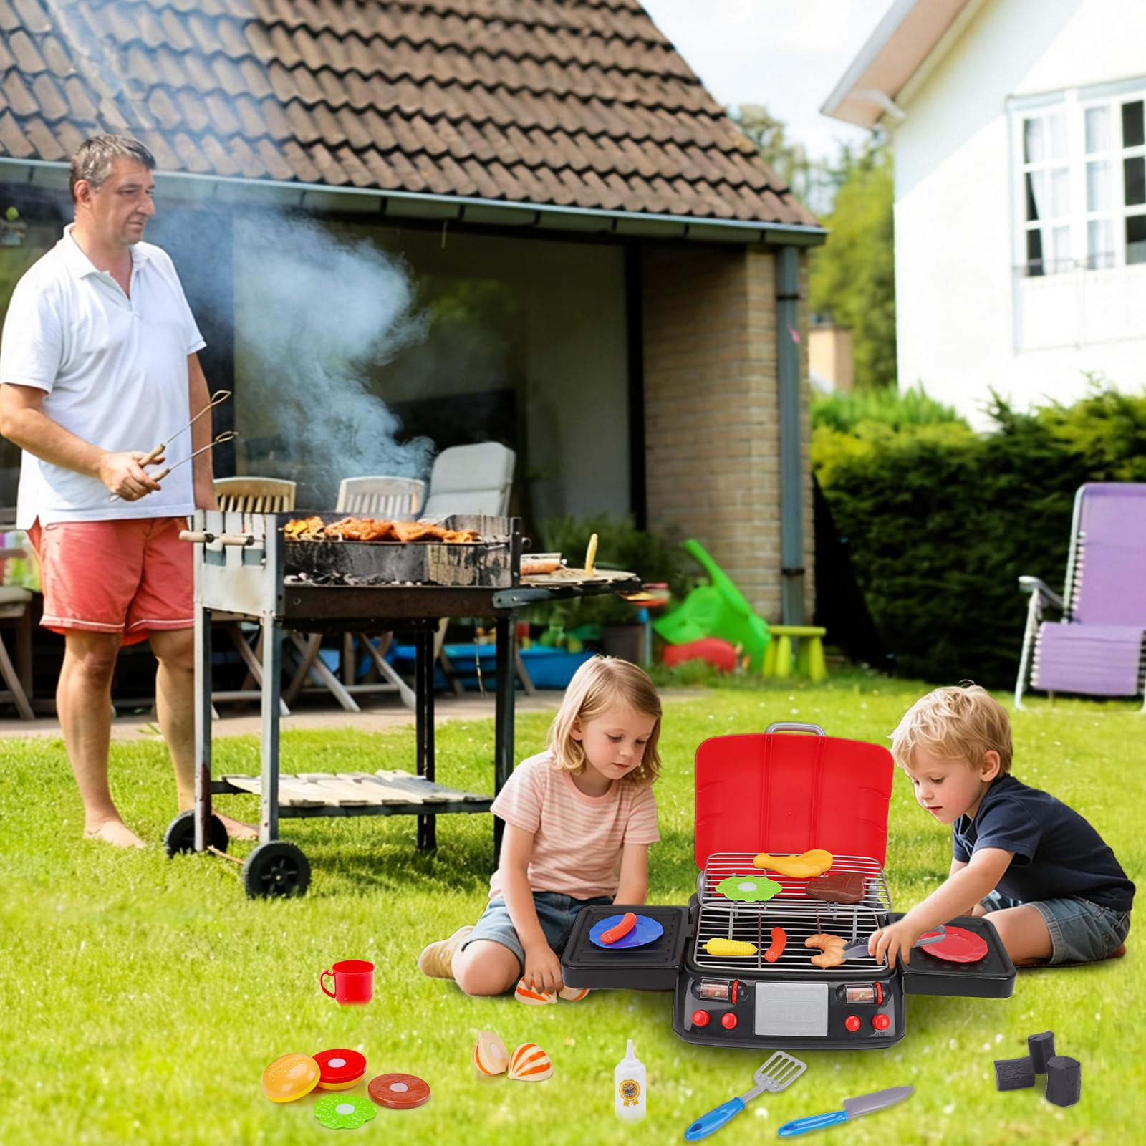
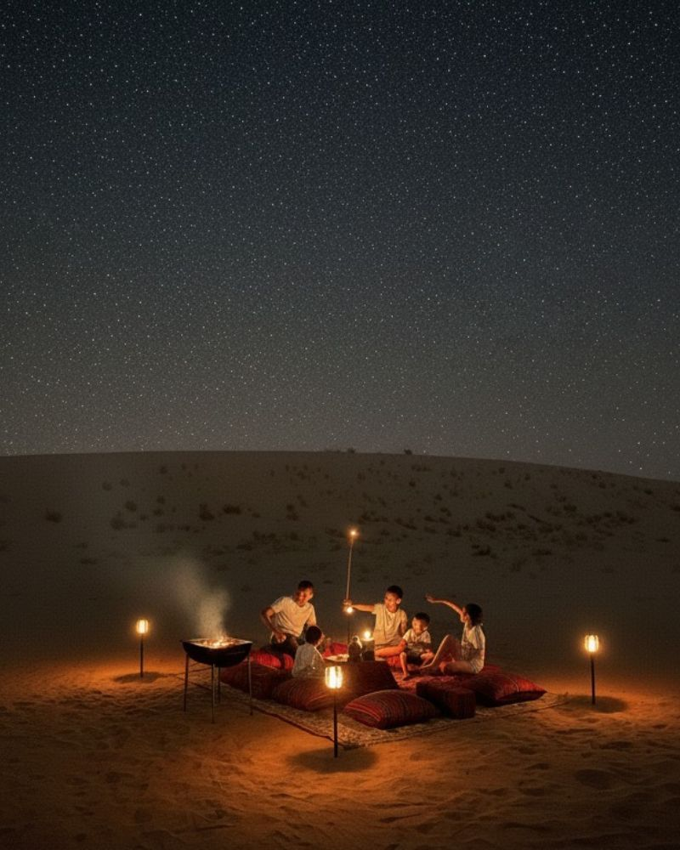
4
🌟 Perfect Family Setup Includes:
- Iveco motorhome (Remal Campers) for comfort 🚐
- Camping trailer with full outdoor setup
- RAM popup camper for adventure 🛻
- BBQ grill with family dining 🍖
- Kids play area (toys, mats, lights) 🎈
Ideal for safe, fun, and memorable family trips.

🚐 Iveco Motorhome + BBQ Luxury Setup

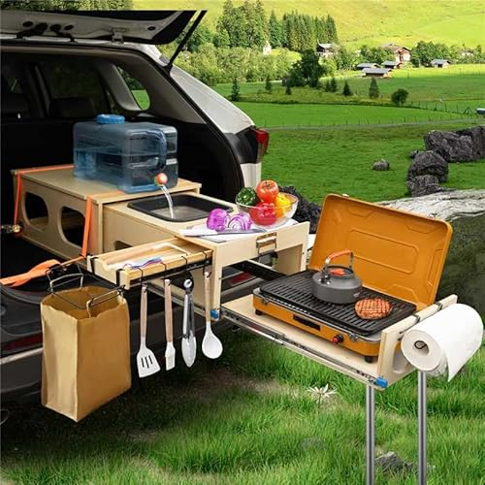
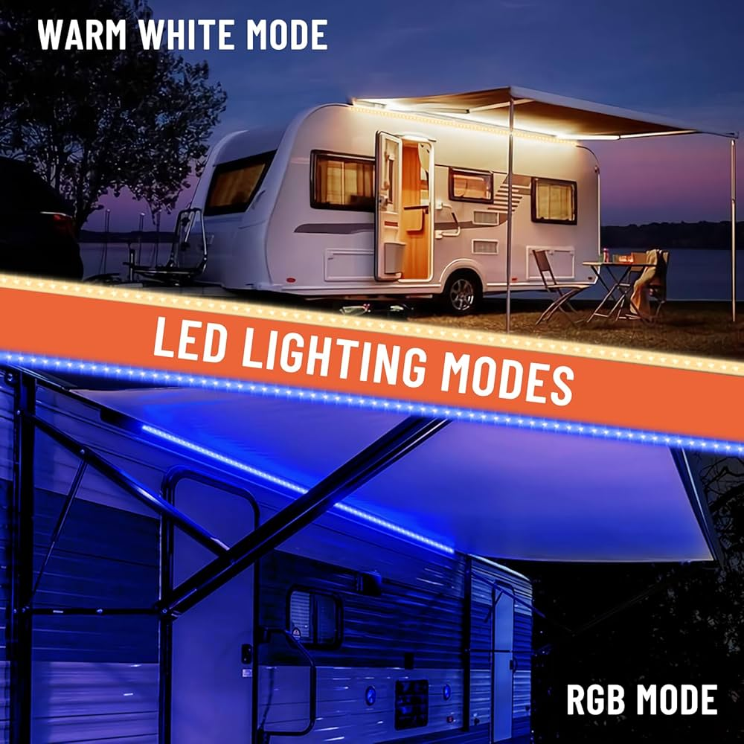
4
Iveco campers provide:
- Comfortable sleeping & kitchen
- Built-in storage and power
- Perfect for long family stays

🛻 Camper Trailers & Popup Truck Campers
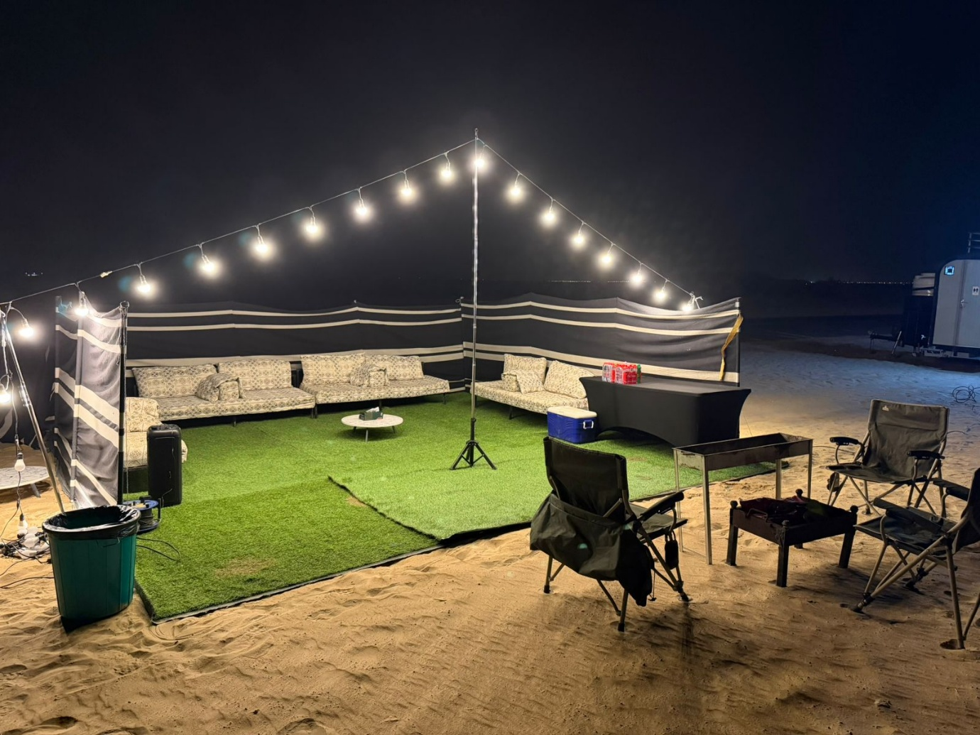
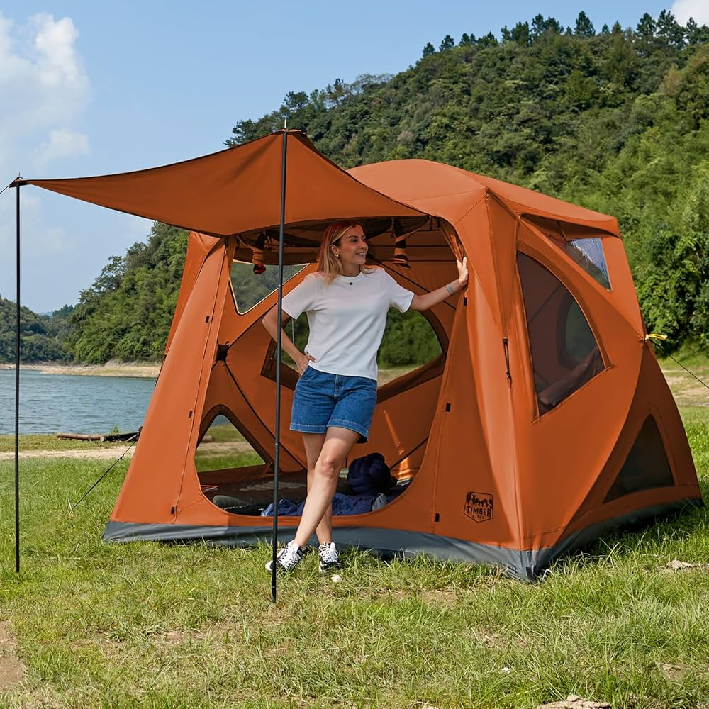
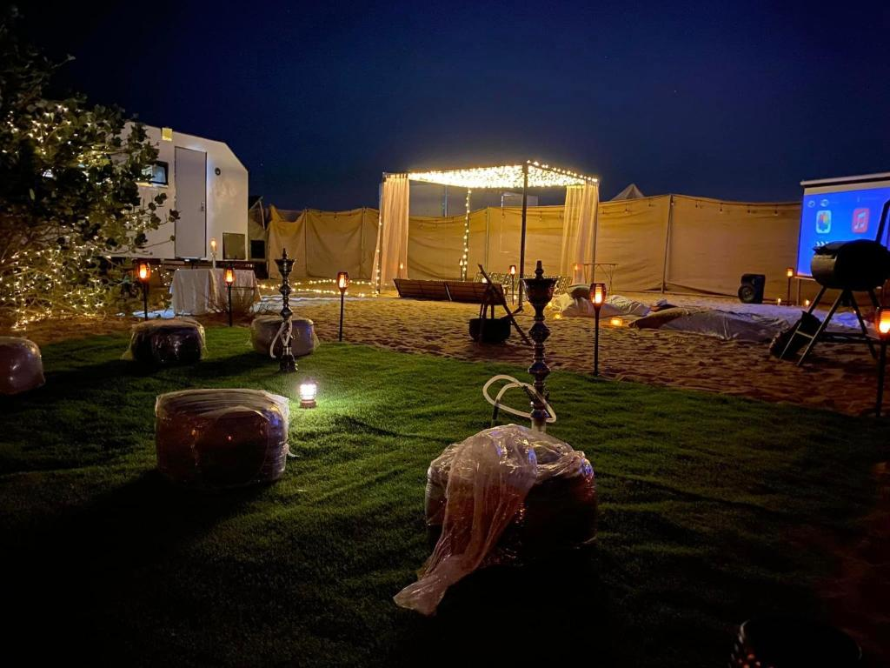
4
These setups are:
- Flexible and budget-friendly
- Easy to tow and set up
- Great for family adventure camping

🏜️ 1. Jebel Hafeet Desert Park – Best Family Camping Spot
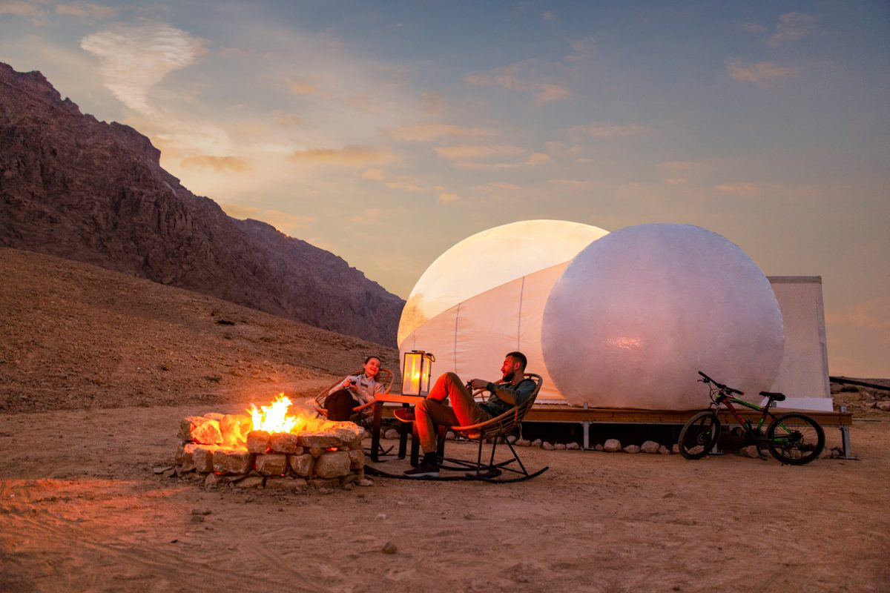
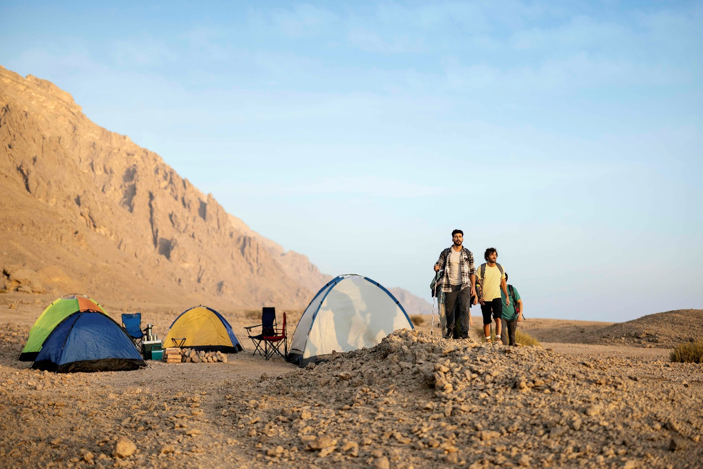
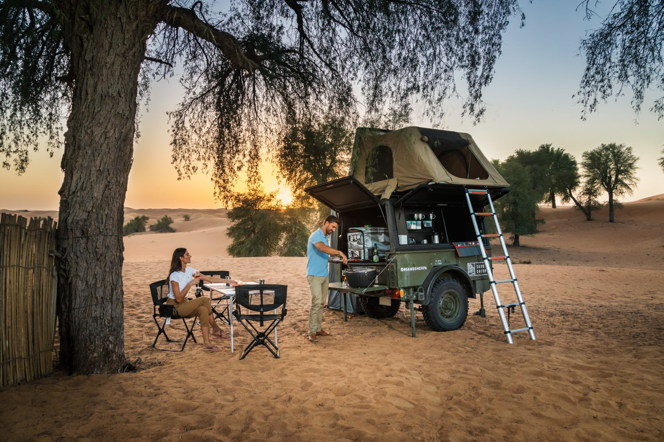
4
Near Jebel Hafeet, this is the most organized camping site.
Why families love it:
- Safe environment for kids 👨‍👩‍👧‍👦
- Facilities available
- Space for BBQ & outdoor setup

🏜️ 2. Al Khaznah Desert – Private Family Camping
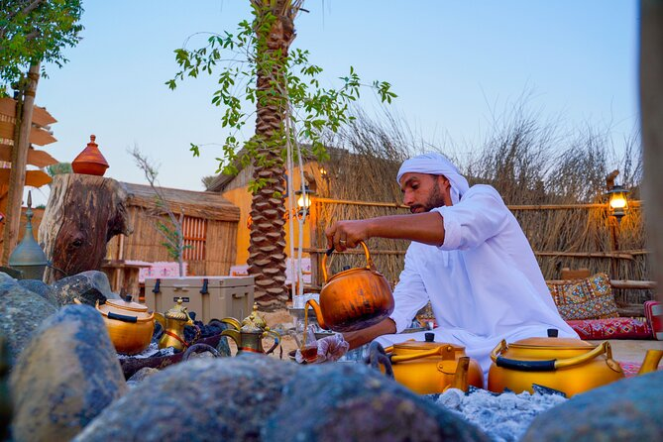
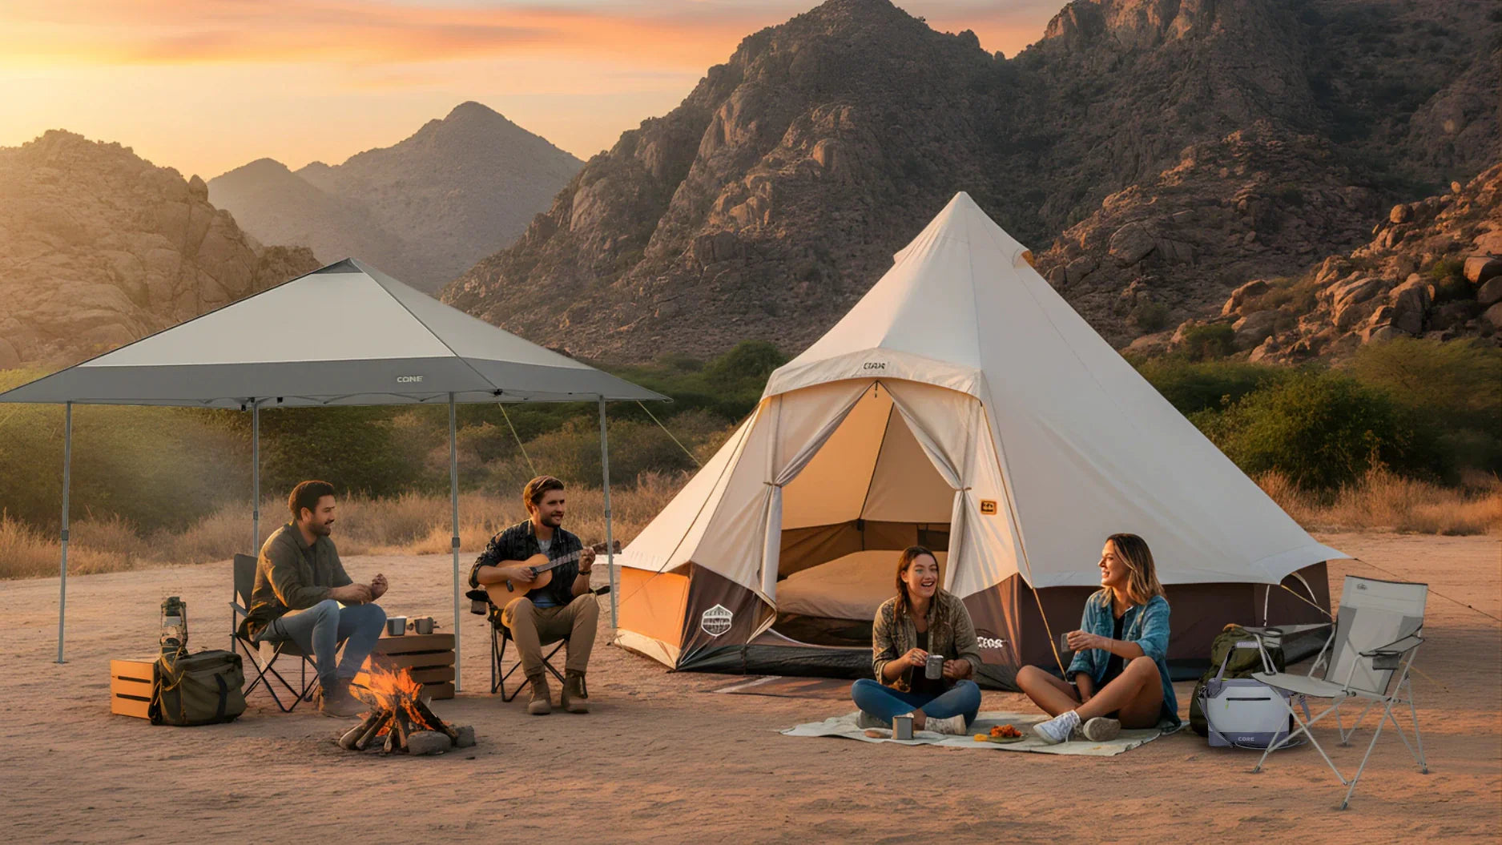
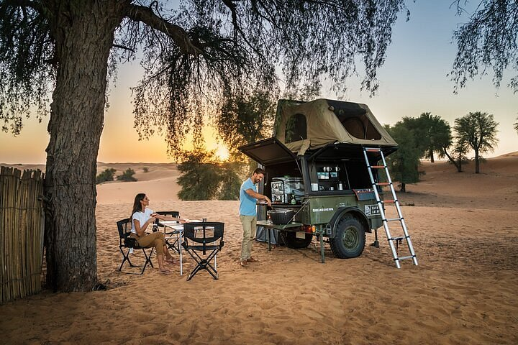
4
In Al Khaznah:
- Quiet & private camping
- Perfect for kids to play safely
- Ideal for BBQ nights and stargazing 🌌

🏜️ 3. Sweihan Desert – Adventure for Families

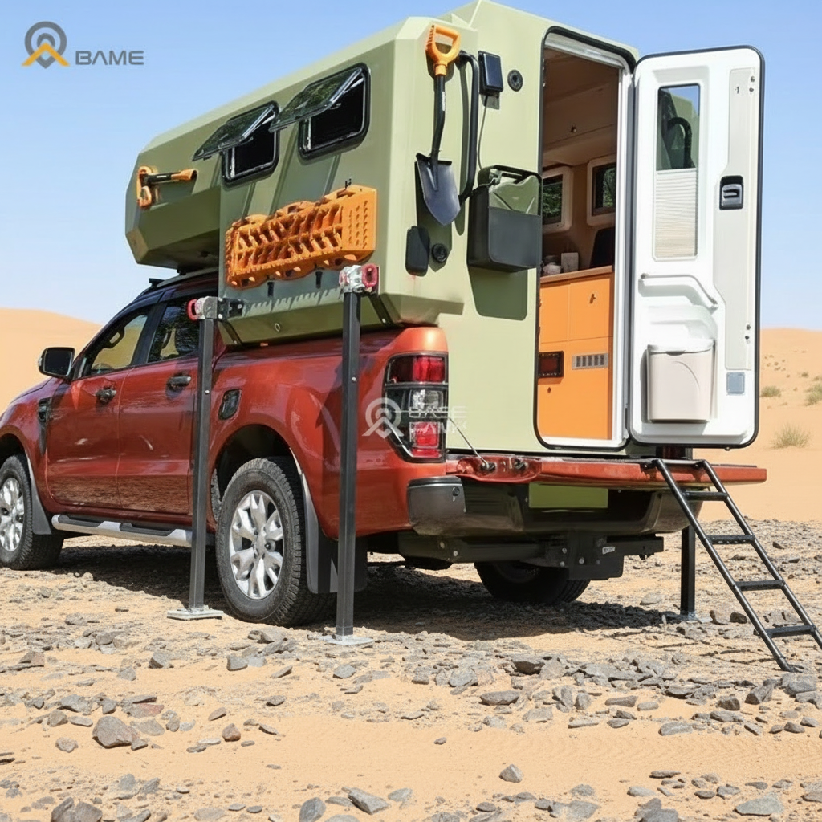
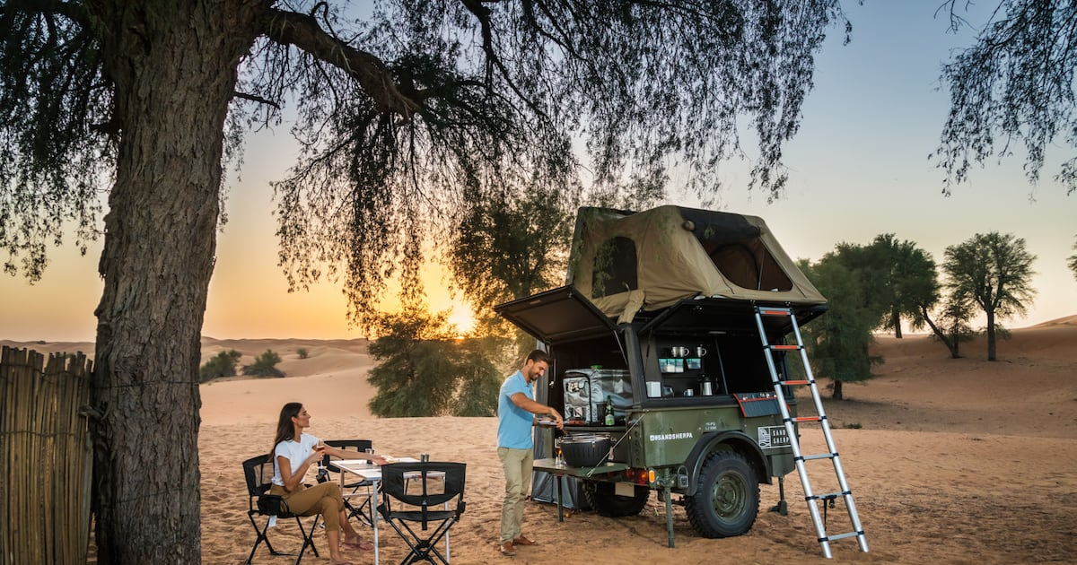
4
At Sweihan:
- Great for 4x4 popup campers
- Fun dune activities for families
- Adventure + relaxation combined

🍖 Remal Campers Rental – Family Camping Made Easy
✔️ What You Get:
- Fully equipped Iveco motorhomes & camper trailers
- RAM popup campers for off-road trips
- BBQ setup + outdoor furniture
- Lighting & safety equipment
✔️ Designed For:
- Families with kids 👨‍👩‍👧‍👦
- Weekend getaways
- Luxury outdoor experiences

🌟 Final Thoughts
Camping in Al Ain with Remal Campers Rental transforms a simple trip into a family adventure full of comfort, fun, and unforgettable moments. Whether it’s kids playing under the stars or enjoying BBQ beside your motorhome, this is premium camping at its best.

👉 Next, I can:
- Add your real Remal camper photos into these scenes (with your branding)
- Create Instagram ads with family camping theme
- Design a professional rental brochure or flyer

Voice

Ajman Motorhome Camping
You’re viewing user-generated content that may be unverified or unsafe.
Report
🏕️ Al Ain Camping Sites for Motorhomes & Popup Truck Campers
(Remal Campers Rental Edition 🚐✨)
Al Ain is one of the best family-friendly camping destinations in the UAE, combining desert landscapes, mountain views, and peaceful nature. With Remal Campers Rental, you can enjoy a complete experience using Iveco motorhomes, camper trailers, and RAM popup truck campers—all set up with BBQ, lighting, and family comfort.

👨‍👩‍👧‍👦 Family Camping Setup (Kids + BBQ + Trailers & Motorhomes)



4
🌟 Perfect Family Setup Includes:
- Iveco motorhome (Remal Campers) for comfort 🚐
- Camping trailer with full outdoor setup
- RAM popup camper for adventure 🛻
- BBQ grill with family dining 🍖
- Kids play area (toys, mats, lights) 🎈
Ideal for safe, fun, and memorable family trips.

🚐 Iveco Motorhome + BBQ Luxury Setup



4
Iveco campers provide:
- Comfortable sleeping & kitchen
- Built-in storage and power
- Perfect for long family stays

🛻 Camper Trailers & Popup Truck Campers



4
These setups are:
- Flexible and budget-friendly
- Easy to tow and set up
- Great for family adventure camping

🏜️ 1. Jebel Hafeet Desert Park – Best Family Camping Spot



4
Near Jebel Hafeet, this is the most organized camping site.
Why families love it:
- Safe environment for kids 👨‍👩‍👧‍👦
- Facilities available
- Space for BBQ & outdoor setup

🏜️ 2. Al Khaznah Desert – Private Family Camping



4
In Al Khaznah:
- Quiet & private camping
- Perfect for kids to play safely
- Ideal for BBQ nights and stargazing 🌌

🏜️ 3. Sweihan Desert – Adventure for Families



4
At Sweihan:
- Great for 4x4 popup campers
- Fun dune activities for families
- Adventure + relaxation combined

🍖 Remal Campers Rental – Family Camping Made Easy
✔️ What You Get:
- Fully equipped Iveco motorhomes & camper trailers
- RAM popup campers for off-road trips
- BBQ setup + outdoor furniture
- Lighting & safety equipment
✔️ Designed For:
- Families with kids 👨‍👩‍👧‍👦
- Weekend getaways
- Luxury outdoor experiences

🌟 Final Thoughts
Camping in Al Ain with Remal Campers Rental transforms a simple trip into a family adventure full of comfort, fun, and unforgettable moments. Whether it’s kids playing under the stars or enjoying BBQ beside your motorhome, this is premium camping at its best.

👉 Next, I can:
- Add your real Remal camper photos into these scenes (with your branding)
- Create Instagram ads with family camping theme
- Design a professional rental brochure or flyer

